**Rafik’s kitchen Expenses Analysis – 2022**

**Over-Viewing the data**

SELECT * FROM [Expenses 2022]

**KPI’s Analysis**

1. **Total Expenses**

SELECT FORMAT(SUM(PAID),'C','EN-IN') AS TOTAL_EXPENSES FROM [Expenses 2022]

**OUTPUT:**



1. **Monthly Expenses**

SELECT DATENAME(MONTH,DATE) AS MONTH,

FORMAT(SUM(FINAL_AMOUNT),'C','EN-IN') AS EXPENSES_AMOUNT

FROM [Expenses 2022] GROUP BY DATEPART(MONTH,DATE),DATENAME(MONTH,DATE)

ORDER BY DATEPART(MONTH,DATE)

**OUTPUT:**

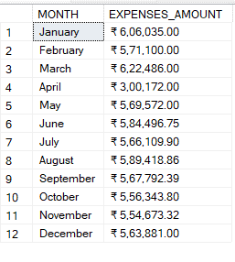

1. **Categorical Expenses**

SELECT EXPENSES AS CATEGORY, FORMAT(SUM(FINAL_AMOUNT),'C','EN-IN') AS AMOUNT

FROM [Expenses 2022] WHERE FINAL_AMOUNT <> 0

GROUP BY EXPENSES ORDER BY SUM(FINAL_AMOUNT) DESC

**OUTPUT:**

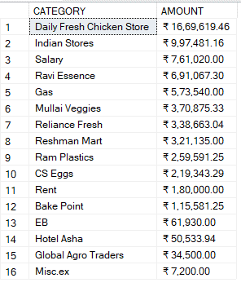

1. **Total Credit Amount & Percentage of Credit Purchase**

SELECT FORMAT(SUM(CARRY_FORWARD), 'C', 'EN-IN') AS TOTAL_CREDIT_AMOUNT,

FORMAT(SUM(CARRY_FORWARD) * 100 / (SELECT SUM(FINAL_AMOUNT) FROM [Expenses 2022]), 'N2')

+ '%' AS PERCENTAGE_OF_CREDIT_PURCHASE

FROM [Expenses 2022]

**OUTPUT:**

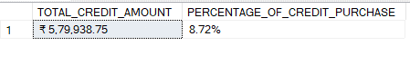

1. **Credit Amount & Percentage by Category**

SELECT EXPENSES, FORMAT(SUM(CARRY_FORWARD), 'C', 'EN-IN') AS CREDIT_AMOUNT,

FORMAT(SUM(CARRY_FORWARD) * 100 / (SELECT SUM(FINAL_AMOUNT) FROM [Expenses 2022]), 'N2')

+ '%' AS PERCENTAGE_OF_CREDIT_PURCHASE FROM [Expenses 2022] WHERE CARRY_FORWARD <> 0

GROUP BY EXPENSES

ORDER BY PERCENTAGE_OF_CREDIT_PURCHASE DESC

**OUTPUT:**

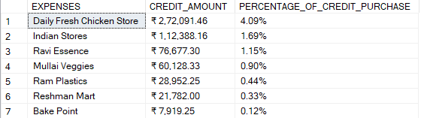

1. **Monthly Credit Amount & Percentage of Credit Purchase**

SELECT DATENAME(MONTH,DATE) AS MONTH,

FORMAT(SUM(CARRY_FORWARD), 'C', 'EN-IN') AS CREDIT_AMOUNT,

FORMAT(SUM(CARRY_FORWARD) * 100 / (SELECT SUM(FINAL_AMOUNT) FROM [Expenses 2022]) 'N2')

+ '%' AS PERCENTAGE_OF_CREDIT_PURCHASE FROM [Expenses 2022]

GROUP BY DATEPART(MONTH,DATE),DATENAME(MONTH,DATE)

ORDER BY DATEPART(MONTH,DATE)

**OUTPUT:**

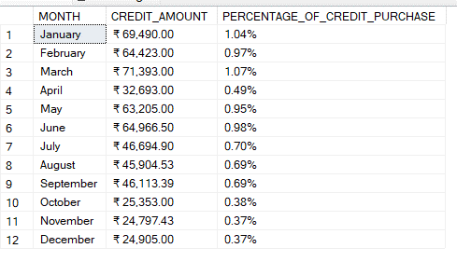

1. **Yearly Expenses for Salary, Rent, EB and Percentage of Selected Expenses**

SELECT EXPENSES AS CATEGORY, FORMAT(SUM(FINAL_AMOUNT), 'C', 'EN-IN') AS AMOUNT,

FORMAT(SUM(FINAL_AMOUNT) * 100.0 / (SELECT SUM(FINAL_AMOUNT) FROM [Expenses 2022]), 'N2')

+ '%' AS PERCENTAGE_OF_EXPENSES FROM [Expenses 2022]

WHERE EXPENSES IN ('SALARY', 'RENT', 'EB')

GROUP BY EXPENSES ORDER BY EXPENSES DESC;

**OUTPUT:**

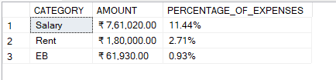

1. **Monthly Expenses for Salary, Rent, EB & Percentage of Selected Expenses**

SELECT DATENAME(MONTH,DATE) AS MONTH, FORMAT(SUM(FINAL_AMOUNT), 'C', 'EN-IN') AS AMOUNT, FORMAT(SUM(FINAL_AMOUNT) * 100.0 / (SELECT SUM(FINAL_AMOUNT) FROM [Expenses 2022]), 'N2') + '%' AS PERCENTAGE_OF_EXPENSES FROM [Expenses 2022] WHERE EXPENSES IN ('SALARY', 'RENT', 'EB') GROUP BY DATEPART(MONTH,DATE),DATENAME(MONTH,DATE) ORDER BY DATEPART(MONTH,DATE)

**OUTPUT:**

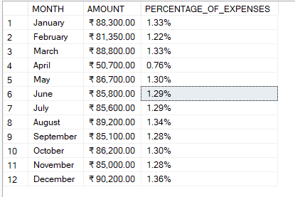

1. **Total Discount Amount by Category**

SELECT EXPENSES AS CATEGORY, FORMAT(SUM(DISCOUNT),'C','EN-IN') AS DISCOUNT_AMOUNT

FROM [Expenses 2022] WHERE DISCOUNT <> 0 GROUP BY EXPENSES

ORDER BY SUM(DISCOUNT) DESC

**OUTPUT:**

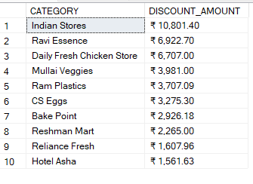

1. **Percentage of Discount by Category**

SELECT EXPENSES AS CATEGORY,

FORMAT(SUM(DISCOUNT) * 100 / (SELECT SUM(FINAL_AMOUNT) FROM [Expenses 2022]),'N2')

+ '%' AS PERCENTAGE_OF_DISCOUNT

FROM [Expenses 2022] WHERE DISCOUNT <> 0

GROUP BY EXPENSES ORDER BY PERCENTAGE_OF_DISCOUNT DESC

**OUTPUT:**

